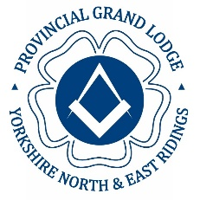 | Masonic Province of Yorkshire  North and East Ridings | 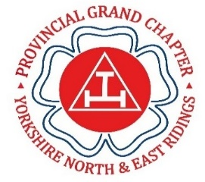

YNER Festival 2029.

Brethren,

During previous Festivals many lodges and chapters made donations by cheque and sometimes presented to a visiting Representative of the RWPGM/MEGS. This created a great deal of administration for all concerned. To reduce the administration for all, the Festival Committee would like the help of all lodges, chapters and Representatives by following the guidance notes attached to this email.

Should you have any questions regarding any of the attached documents, then please do not hesitate to contact the below.

Sincerely and Fraternally.

